Software Requirements Specification
for
Moosnick Medical Museum Website
Version 1.0.0 approved
Prepared by Christine Lee and Francesco Serio
Transylvania University
February 14, 2020
Table of Contents
Table of Contents ii
Revision History ii
1. Introduction 1
1.1 Purpose 1
1.2 Document Conventions 1
1.3 Intended Audience and Reading Suggestions 1
1.4 Project Scope 1
1.5 References 2
2. Overall Description 2
2.1 Product Perspective 2
2.2 Product Features 2
2.3 User Classes and Characteristics 2
2.4 Operating Environment 3
2.5 Design and Implementation Constraints 3
2.6 User Documentation 3
2.7 Assumptions and Dependencies 3
3. System Features 3
3.1 Intuitive Design 3
4. External Interface Requirements 4
4.1 User Interfaces 4
4.2 Hardware Interfaces 4
4.3 Software Interfaces 4
4.4 Communications Interfaces 4
5. Other Nonfunctional Requirements 5
5.1 Performance Requirements 5
5.2 Safety Requirements 5
5.3 Security Requirements 5
5.4 Software Quality Attributes 5
6. Timeline 6
Appendix A: Glossary 7
Appendix B: Analysis Models 8
Appendix C: Issues List 11

Revision History
Name | Date | Reason For Changes | Version
Christine Lee,  Francesco Serio | 2/14/20 | Initial version | 1.0.0

Introduction

Purpose
The purpose of this document is to specify the requirements for the Moosnick Medical Museum (MMM) website Version 1.0.0. The scope of the product covered in this SRS is currently limited to the front-end which the group will be creating (part of the overall system), with limited reference to the back-end interfacing.

Document Conventions
Underlined words will appear in the glossary in Appendix A. The font for the document is in Times New Roman. For the main headings, they are in size 18, bolded. The main headings have an Arabic number followed by a period, then the heading name. The subheadings are in size 14, bolded. The subheadings have an Arabic number followed by a period, then another Arabic number, then the subheading name. The sub-subheadings are not bolded, size 12, with additional period and Arabic number followed with the name. The text bodies are in Times New Roman, size 11. Versions appear in the following format: “Version x.x.x” where each “x” is an Arabic numeral; the first “x” represents the major version, the second, the minor version, and the third, the revision.

Intended Audience and Reading Suggestions
The intended audiences for the entirety of the document are the members of the project group and Dr. Moorman. The two clients- Dr. Day and Dr. England - should focus on sections 3-6 for the requirements of the product. Specifically, Dr. Day should focus on 3 and 4 to read about the graphical interfacing of the product. Dr. England should give extra attention to sections 5 for nonfunctional requirements that deal with the coding aspect of the product, as well as the intricacies of the back-end portion of the website. The testers of the product should read Appendix C: Issues List if they come across an anomaly to see if the problem is already known to the developers.

Project Scope
The goal of this project is to create a functioning website for the Moosnick Medical Museum. The site will aim to adhere to the most recent of industry standards and serve as an easy medium for users to find the information they seek. The project has the potential to reach a wide range of target audiences, from prospective students of Transylvania to researchers around the world. Current students who may be doing research for school work could simply look online to peruse through the website instead of going through the process of contacting Dr. Day to set up a meeting or a tour in person. If they need the information and not necessarily see it in person, having direct access to the data would be more efficient.

References
Documentation of Firebase gem for Ruby: https://www.rubydoc.info/gems/firebase-ruby
How to get data from Firestore: https://firebase.google.com/docs/firestore/query-data/get-data
TURING Lab Greenbook: http://www.cs.transy.edu/documents/greenbook.html
Color Palette Generator: http://www.coolers.co

Overall Description

Product Perspective
The product is new and will interface with an existing Firestore Database using Ruby and Apache 2. Figure 1, found in Appendix B shows a simplified interaction model between the three major parts of the system.

Product Features
The product will consist of a landing (home) page with a navigation bar containing clickable tabs named “About,” “Collection,” “News,” “Donate,” and “Tour.” The “Collection” tab will bring the user to another page with the various categories available to peruse (i.e Anatomy, Instruments (Medical/Scientific), Natural History, and Misc). Clicking any of these categories will lead the user to a new page with a set of subsections, further specifying what items the user wants to browse (i.e. the subsections for Natural History will be Birds and Not Birds). Clicking on one of the subsections will show the user the following per item (if the information is available from the database): the name of an item in the museum, the date of manufacture of the item, a description of the item, an image of the item, a link to more information about the item, keywords related to the item, the location of the item on Transylvania University’s campus, and the manufacturer of the item. At any point the user can go back to the landing page by clicking the logo on the top of the page (header). For a visual representation of the navigation, refer to Figure 2 in Appendix B.

User Classes and Characteristics
Because the product is meant for any and everyone who wants to use it, and because the focus of the group is on building the front-end of the website, user classes are of no concern to the group. All users will have access to the same experience on the website. Currently, there is no way to access the database through the website itself, therefore there is no privilege level regarding modification of the database. The website is simply a medium for the user to view information, not change information.

Operating Environment
The product should accommodate a wide variety of machines and operating systems. A requirement for the user to utilize this product is a web browser in combination with an internet connection.

Design and Implementation Constraints
- The required database the product must use is Firestore.
- The product is bound to the server that the TURING Lab uses, which is Apache 2.
- Dr. England is responsible for maintaining the product after the final product is released.

User Documentation
One of the main goals of the product is to be intuitive for the users to navigate through the website without the need to refer to documentation. Therefore, there is no user documentation available.

Assumptions and Dependencies
- The user has to have an internet connection.
- The Apache server has to be up and running.
- Google’s Firebase services have to be up and running.
- The Firestore database the product is dependent on has to exist, and have data.
- The website will have a “News” section that should contain external information. The functionality depends on the external links and pages existing and functioning.

System Features

Intuitive Design
3.1.1 Description and Priority
The user should not require a separate document or help in order to navigate throughout the website. Intuitive design holds the highest priority.
3.1.2 Stimulus/Response Sequences
Refer to Figure 2 in Appendix B, where each branch represents the path from a page to another. The figure is divided into sections of how many clicks a user has to take to get to the desired page in order to get the information the user needs. The final destination is shown in green.
3.1.3 Functional Requirements
1-1: The user should not use more than three clicks/touches to navigate to the desired page.
1-2: The user should not require navigational assistance in order to reach the goal page.
1-3: An error will be displayed if a page a user is trying to access is not available.
1-4: TBD: Placeholder pages will be used for pages that are not yet complete.

External Interface Requirements

User Interfaces
Refer to Figure 3 of Appendix B to see a mock-up of the Landing Page. The header and footer will be constant throughout the pages, as well as the location of the logo and the navigation tabs. Figure 4 is the original design in Nicholson’s British Encyclopedia on Dictionary of Arts and Sciences. The logo for the website will borrow the style of Figure 4, shown in Figure 5. The overall color palette will adhere to a final color scheme similar to the example shown in Figure 6.

Hardware Interfaces
The website will be dynamic and able to be used on mobile, tablet, and computer. Each user’s hardware will differ so the speed of website navigation will vary. Internet connections will also differ, affecting navigation speed.

Software Interfaces
This product, in version 1.0, will interact with the Firebase 1.9.1 as a back-end using the Google-provided Ruby gem for Firestore with the front-end using HTML5, CSS3 and will run on Windows 10 machines with version 1909 or earlier, MacOS Catalina 10.15.3 or earlier, and Ubuntu with version 18.04 or earlier. The data will be accessible through a Ruby script querying data from Firestore and may contain the name of an item in the museum, the date of manufacture of the item, a description of the item, an image of the item, a link to more information about the item, keywords related to the item, the location of the item on Transylvania University’s campus, and the manufacturer of the item. These will be displayed on the website, which will be accessible through Firefox, Internet Explorer, Google Chrome, and Safari.

Communications Interfaces
The user needs a web browser to access the product. The product will be using HTTP as the communication standard because of the use of an Apache Server.

Other Nonfunctional Requirements

Performance Requirements
The product should be tested across major hardware and software platforms. For hardware platforms, the following will be tested: smartphones, computers, and tablets. For software platforms, the following operating systems will be tested: Mac, Windows, Linux, iOS, and Android.

Safety Requirements
Those who are prone to episodes of epilepsy by visual triggers should use caution when using our product. There are no plans to use flashing imagery during the development of the product, however there is no guarantee that those who will take over the maintenance of the product after us will not include flashing imagery. The links that are included in our “News” section may lead to sites that do have flashing imagery or other visual triggers for epilepsy. This is a medical museum website and might contain information or content that is triggering to some (i.e. bones, taxidermied birds, human anatomy models, preserved remains, etc.). Those triggered by things of the sort should be aware. The links that are included in the “News” section may lead to sites that do have triggers. The group is not responsible for what other sites publish.

Security Requirements
Because the product focus is not on the back-end, and because the website will not have any authentication or sensitive data, security requirements will not be high priority, if at all.

Software Quality Attributes
The product will be easily maintainable, modular, and well documented. Lines of code will be properly commented following the conventions on the TURING Lab Greenbook.

6. Timeline
Goals | Due Date
Final draft of logo finished and approved | 2/17
Navigation Tabs in Header implemented; Footer implemented | 2/18
Mini-Gallery implemented | 2/20
Interesting Tidbits (Figure 3) implemented | 2/20
Custom Buttons for Navigation Tabs implemented | 2/20
Dummy pages for 1 Click pages created (Figure 2) | 2/21
Make pages navigable from Landing page via tabs | 2/21
Requirements 1-2, 1-3 check  User Interfaces check (4.1) | 2/24
Testing Phase 1 | 2/24-2/27
Create mock-ups for Collection page, sub-collection pages (2 Click in Figure 2), and sub-sub collection pages (3 Click in Figure 2) | 2/27
Create mock-ups for About, News, Donate, and Tour pages | 2/29
Collection page finished | 3/2
Sub-collection pages finished | 3/6
Sub-sub collection pages finished | 3/10
Requirement 1-1 check | 3/10
News page finished | 3/16
About page finished | 3/16
Tour page finished | 3/18
Donate page finished | 3/18
Requirements 1-1, 1-2, 1-3 re-check | 3/19
Testing Phase 2 | 3/21-3/25
Refining Phase | 3/26-4/8
Final Client Check | 4/9
Final Client Check (If needed, again) | 4/13

Appendix A: Glossary
Apache: The goal of this project is to provide a secure, efficient and extensible server that provides HTTP services in sync with the current HTTP standards.
API: Application Programming Interface; set of standards for communication across web-based applications
Back-end: This term will refer to the database being utilized for this project, in our case, Firebase.
CSS3: Cascading Style Sheets; the language used for the presentation of a document written in markup language such as HTML
Data: What the database contains; raw
Front-end: The interface the user would utilize to navigate the website, in our case, HTML5.
HTML5: HyperText Markup Language, fifth and current version of the HTML standard
Information: Data presented through the product
MMM: Moosnick Medical Museum
Major Version: For alterations to the product that would affect the API; for example, changing from Firebase as a back-end to MySQL
Minor Version: For updates that do not affect the existing product’s API; for example, changing the background color of the landing page.
Product: The Moosnick Medical Museum website; the project
Revision: For formatting, grammar, or spelling errors
Appendix B: Analysis Models
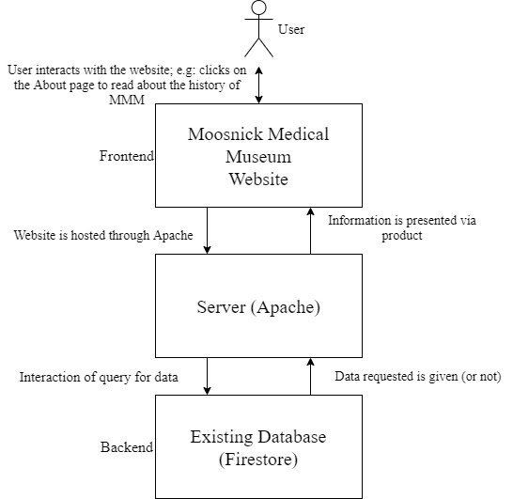
Figure 1: Simplified Interaction Model Between the Three Major Parts of the System
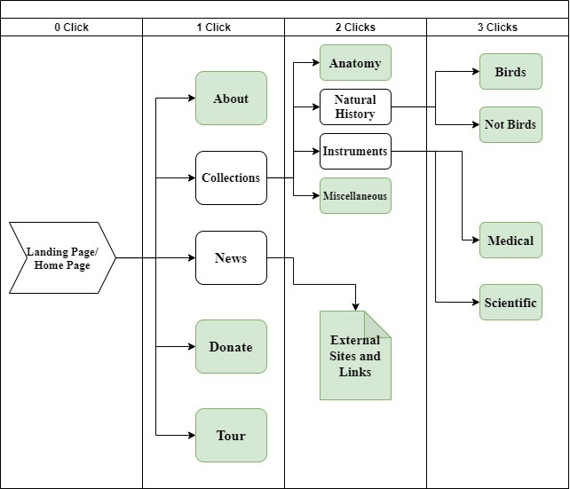
Figure 2: Flow Diagram for Website Navigation
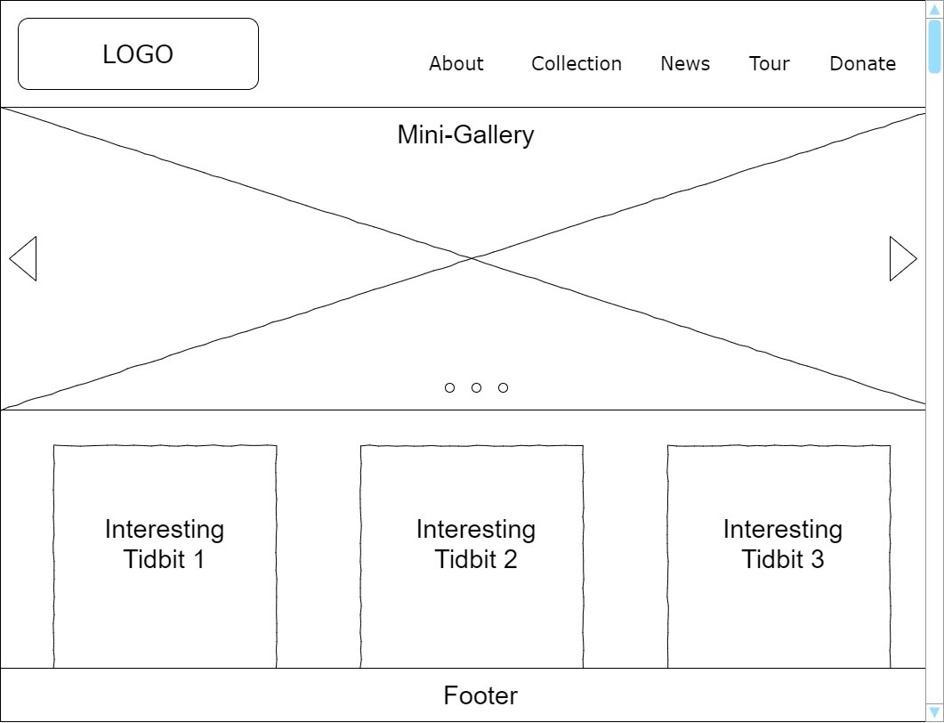
Figure 3: Primitive Mock-up of Landing Page/Home Page


Figure 4: Original Design of a Logo Scheme
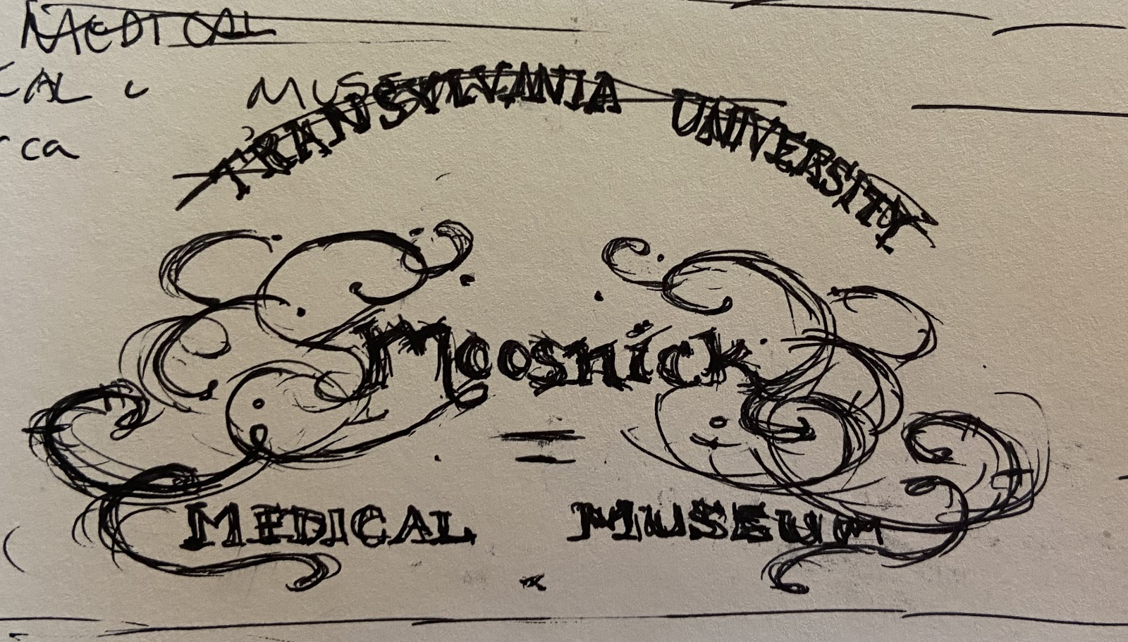
Figure 5: Sketch of Replicated Logo for MMM
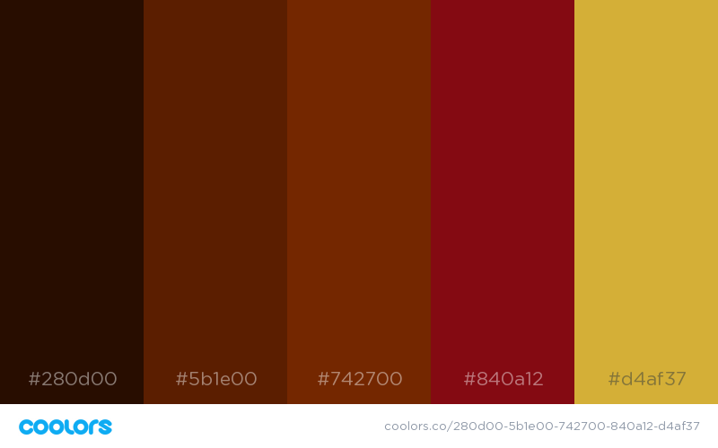
Figure 6: Example Color Palette in Development

Appendix C: Issues List
- Interfacing with Firestore is in progress.
- Specification of requirements regarding code maintainability, modularity, and documentation.
- Specification on User Interface and Experience requirements.
- Aesthetic/Look and Feel requirements need to be objectified further.
- The color palette mentioned in 4.1 is not finalized; the client and the group are in process of drafting and testing the different color combinations.
- Detailed User Interface specification requirements are not included within this document, because the details need to be narrowed down and finalized. Further specification is needed in 4.1.

